**Lab 11**

**Create a new workspace and use the productdb script provided in eLearning. For each problem, enter your query and attach a screen shot of the result set.**

1. **When was the last time that the statistics were updated on the LINE table? Show the query and write the date. (2 pts)**

**Query:**

**analyze table line**

**compute statistics;**

**select * from user_tab_statistics**

**where table_name = 'LINE';**

**Date: 24-APR-2020**

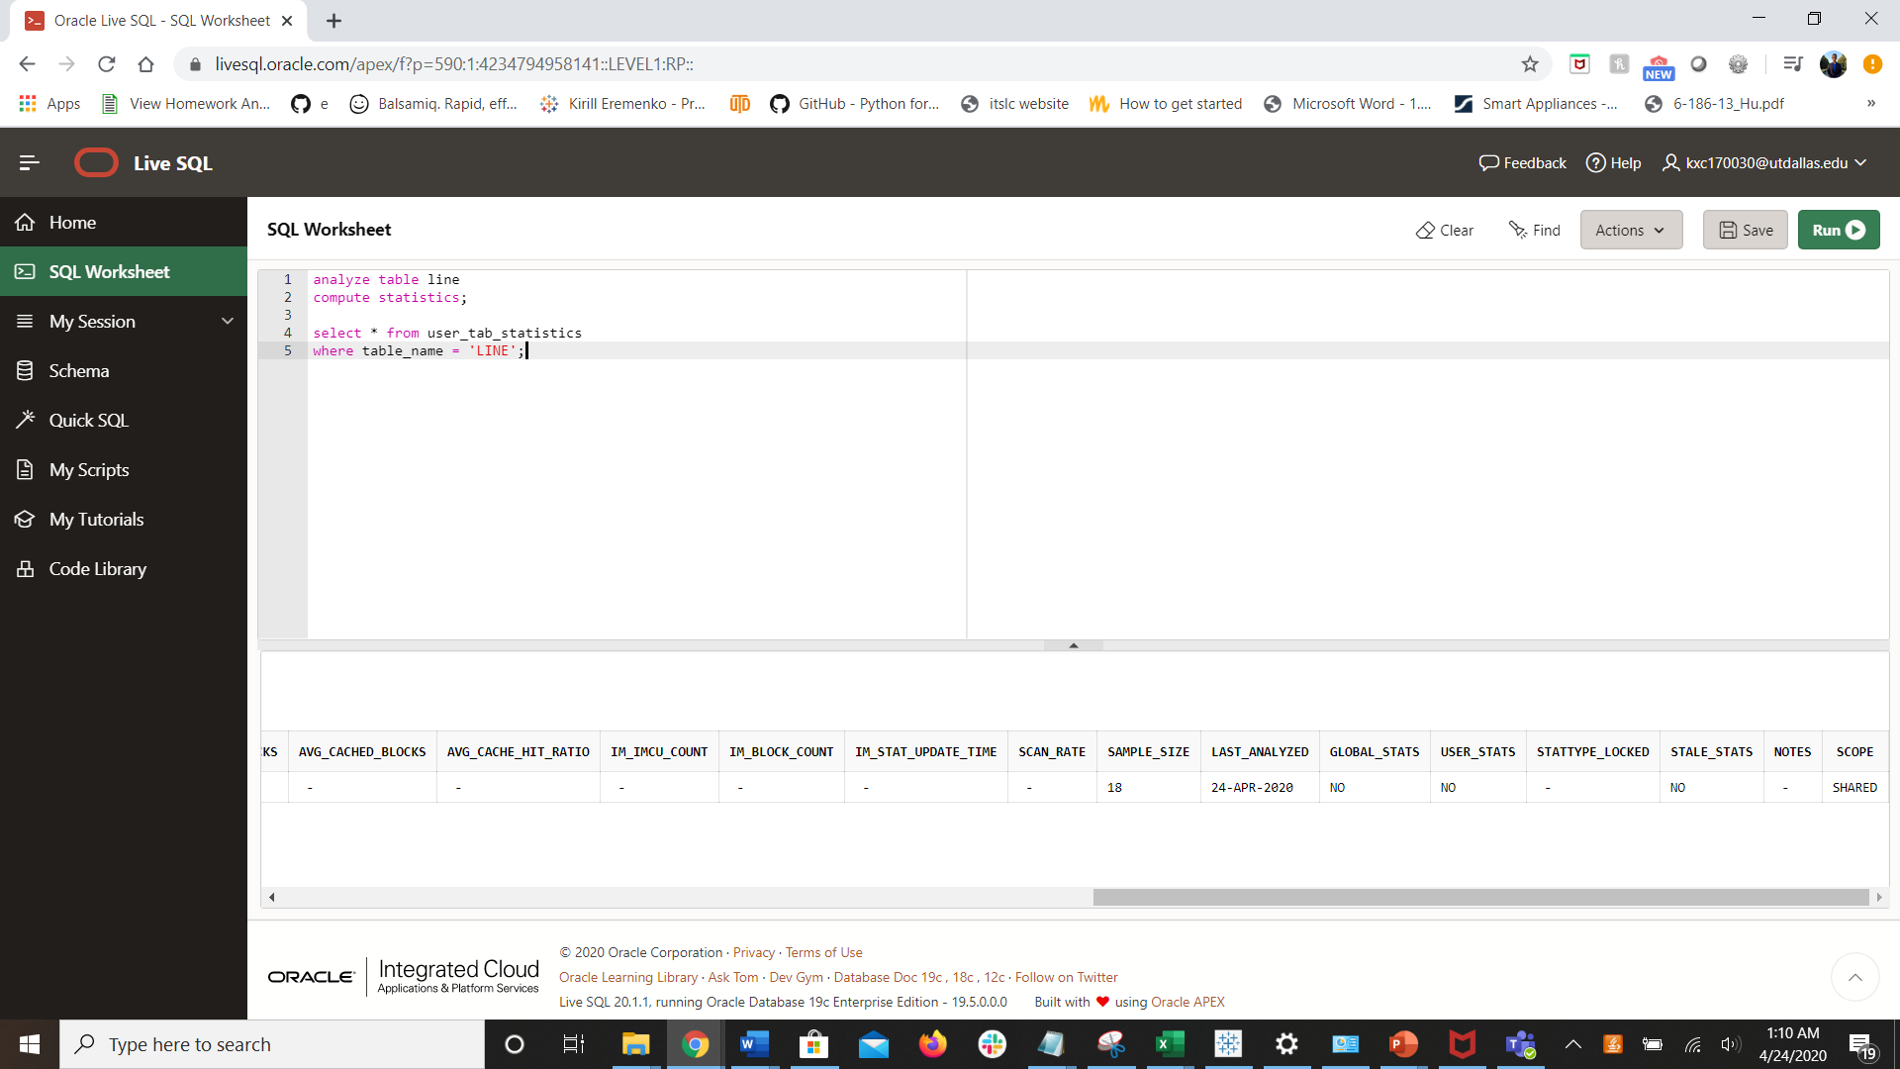

1. **Are there any indexes on the PRODUCT, VENDOR, or LINE tables? Show the query you would use to answer the question and then list any indexes. (2 pts)**

**select \***

**from user_indexes**

**where table_name in ('LINE', 'PRODUCT', 'VENDOR');**

1. **If you want to see the columns that are indexed in an index, which table would you query ? Query that table and look at the line table to see which columns are indexed. (2 pts)**

**user_ind_columns**

**select \***

**from user_ind_columns**

**where table_name = 'LINE';**

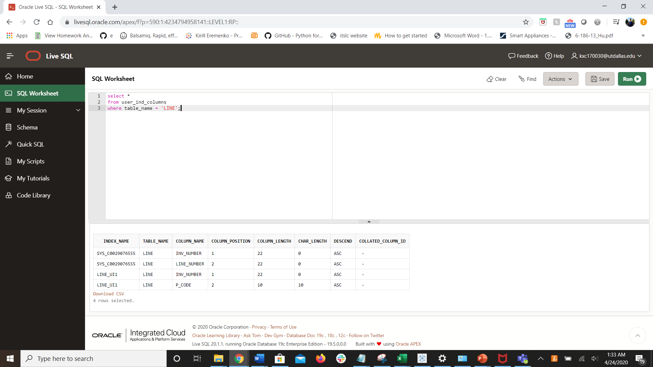

1. **Execute the following query. Run the explain plan for the query and view the results. Add the index on line_units column, run the explain plan and view the results. Make sure that you update the statistics after creating the index. Can you improve performance by adding an index on the line_units column? (3 pts)**

**Query:**

select p_code, sum(line_units)

from line

group by p_code

having sum(line_units) >

(select(max(line_units)) from line)

**explain plan for**

**select p_code, sum(line_units)**

**from line**

**group by p_code**

**having sum(line_units) > (select(max(line_units)) from line);**

**SELECT * FROM table(dbms_xplan.display);**

**create index line_units_index**

**on line (line_units)**

**explain plan for**

**select p_code, sum(line_units)**

**from line**

**group by p_code**

**having sum(line_units) > (select(max(line_units)) from line);**

**SELECT * FROM table(dbms_xplan.display);**

**The performance is improved by adding an index on line_items as the number of rows scanned, number of bytes used, and the cost (%CPU) is reduced.**

**5. Consider the query below. Can you rewrite the query and/or add indexes to improve the performance of the query? Write the new query and list any indexes you created. (There are multiple things you can do to improve the query). Explain the performance improvement gained after making these changes and show the explain plan. (3 pts)**

select p_code, p_descript, p_price, p.v_code, v_state

from product p, vendor v

where p.v_code = v.v_code

and v_state = 'FL'

and v_areacode = '904'

order by p_price

**explain plan for**

**select p_code, p_descript, p_price, p.v_code, v_state**

**from product p, vendor v**

**where p.v_code = v.v_code**

**and v_state = 'FL'**

**and v_areacode = '904'**

**order by p_price;**

**SELECT * FROM table(dbms_xplan.display);**

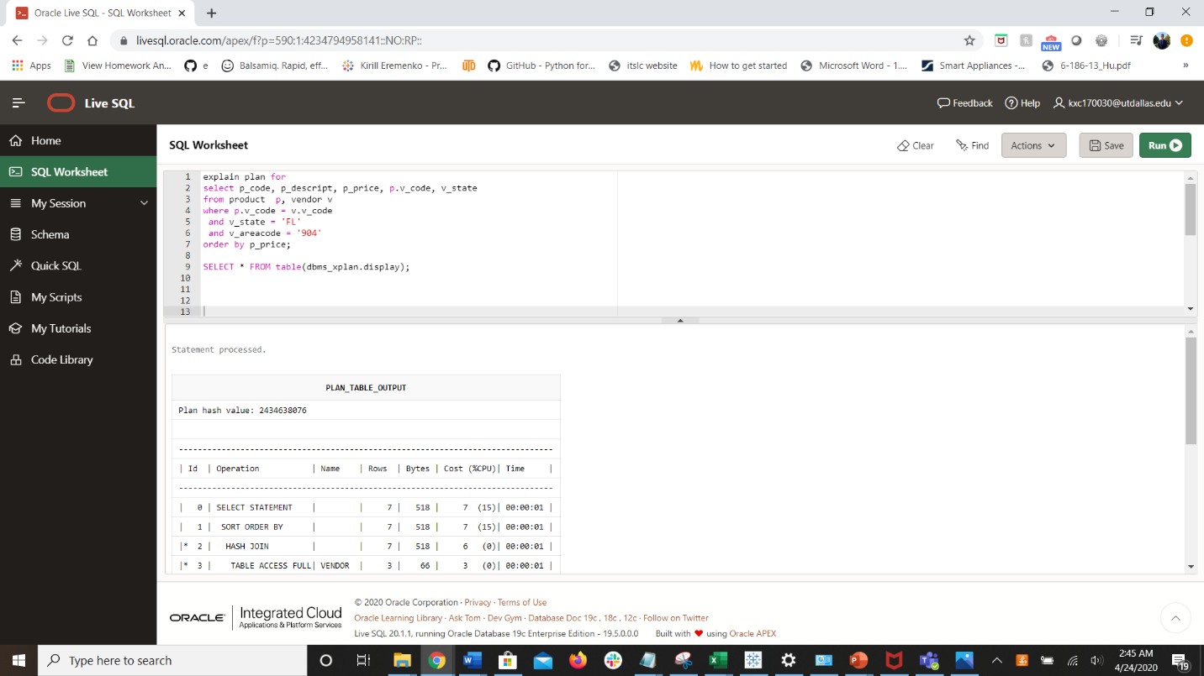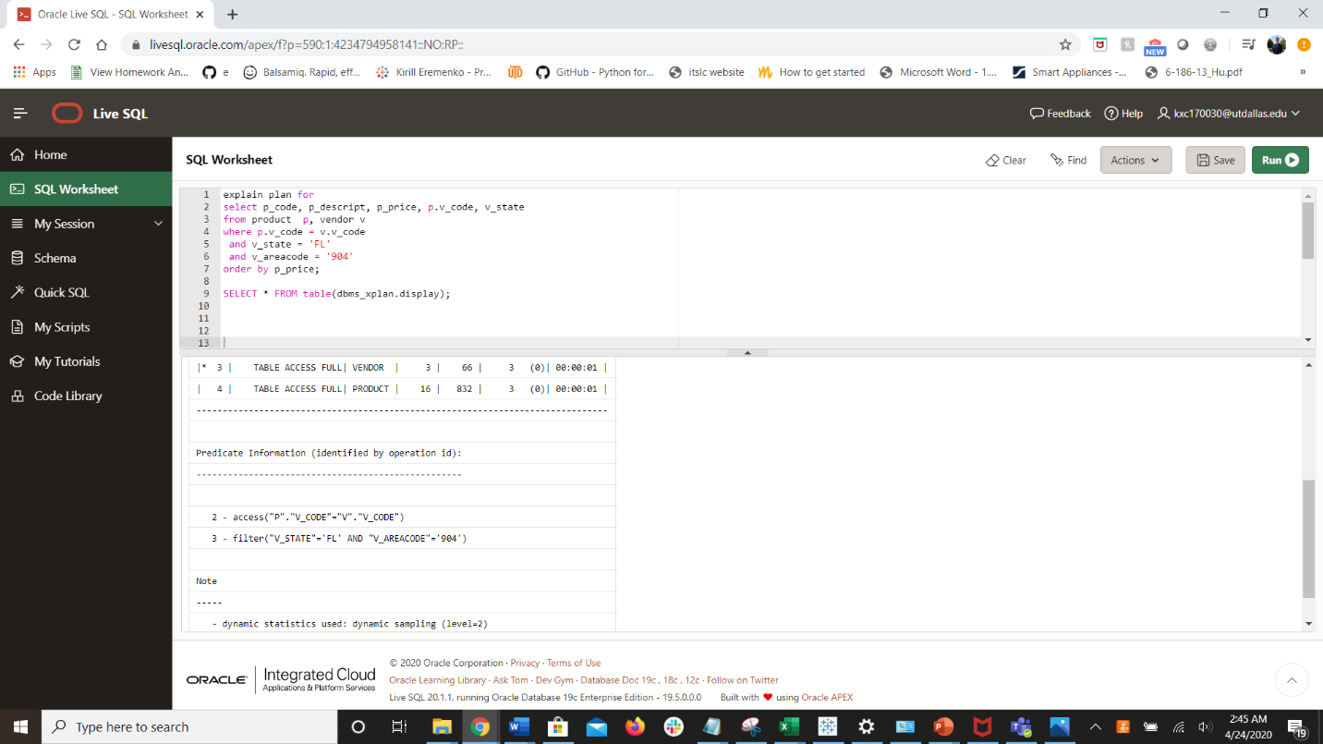

**create index vendor_new_index**

**on vendor (v_code, v_state, v_areacode);**

**/*multiple column index – you can also treat this as 3 indexes*/**

**explain plan for**

**select p_code, p_descript, p_price, p.v_code, v_state**

**from product p, vendor v**

**where p.v_code = v.v_code**

**and v_state = 'FL'**

**and v_areacode = '904';**

**/*removed the order by clause*/**

**SELECT * FROM table(dbms_xplan.display);**

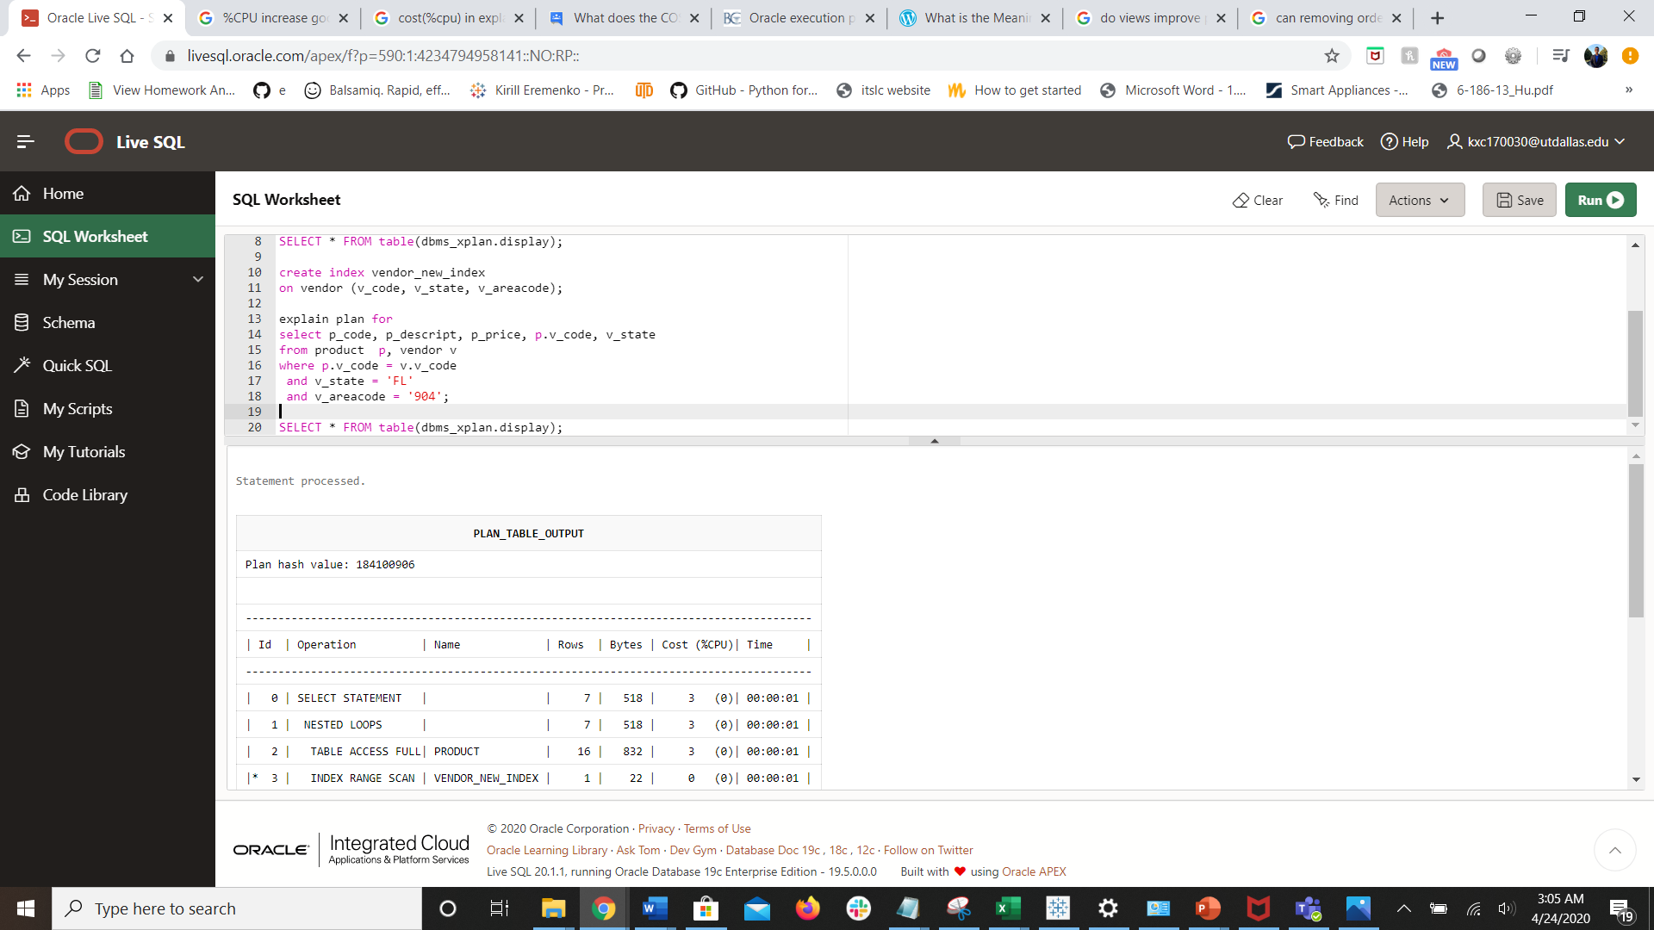

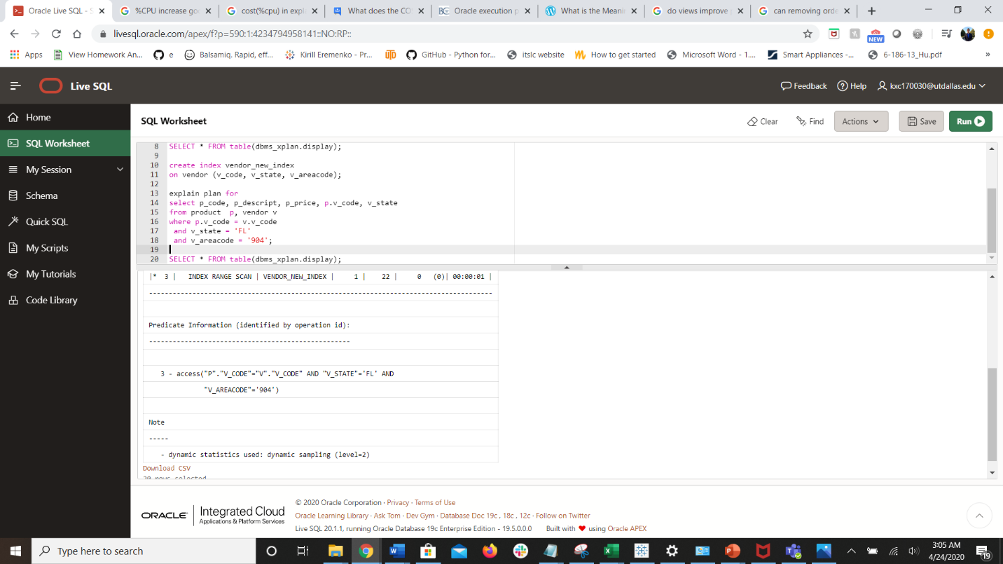

**Performance improvement:**

* **Cost (%CPU) decreases significantly for SELECT STATEMENT**
* **TABLE ACCESS FULL on the VENDOR table is replaced with INDEX RANGE SCAN**
  + **Rows, bytes, and cost (%CPU) decrease significantly**
* **HASH JOIN is replaced with NESTED LOOPS**
  + **Cost (%CPU) decreases**
* **SORT ORDER BY is removed so there are less total rows scanned, bytes used, and cost (%CPU)**